Weekly Monitoring Log for Wednesday, 10/23/17 - Friday, 10/27/17
Current Learning Goal: TSW understand how the Earth’s natural processes have shaped its landscape (including Earthquake locations and how they are measured as well as Volcano locations and the three types). | 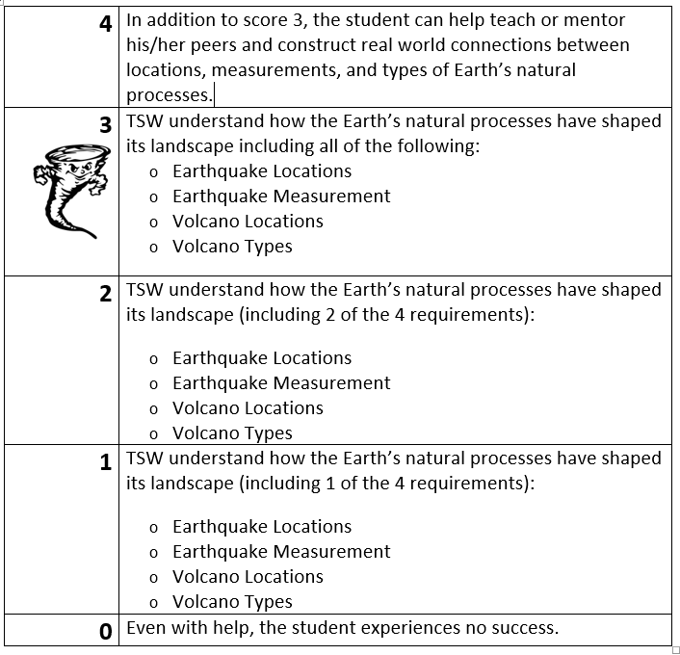

MONDAY:
Response to Warm-Up Prompt: | Today I learned that…
Learning Scale/Rubric Self-Assessment and Justification: | Comments from Mr. Pysher for today:
TUESDAY:
Response to Warm-Up Prompt: | Today I learned that…
Learning Scale/Rubric Self-Assessment and Justification: | Comments from Mr. Pysher for today:
WEDNESDAY:
Response to Warm-Up Prompt: | Today I learned that…
Learning Scale/Rubric Self-Assessment and Justification: | Comments from Mr. Pysher for today:

THURSDAY:
Response to Warm-Up Prompt: | Today I learned that…
Learning Scale/Rubric Self-Assessment and Justification: | Comments from Mr. Pysher for today:

FRIDAY:
Response to Warm-Up Prompt: | Today I learned that…
Learning Scale/Rubric Self-Assessment and Justification: | Comments from Mr. Pysher for today:

Current Science LETTER Grade:___________

Summary of what I learned in science this week:

Other information I want Mr. Pysher to know about my participation/involvement in class this week:

Student Signature:____________________________________ Date:________________

Parent Signature:_____________________________________ Date:________________

